10/27/2011
Vault Links View
Jan Liska has provided us with another Vault sample. This one is a custom tab that shows all the links to the selected entity. It works with files, folders, items or change orders.
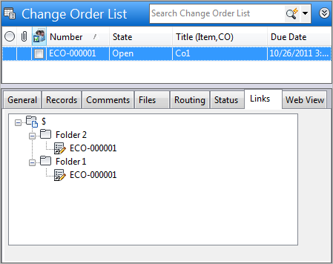
The Where Used tab for files also has the ability to show links. However it only applies to files, and it doesn't show the full folder path. The new Links tab displays the full folder structure.

Requirements:
Vault Workgroup/Collaboration/Professional 2012
Click here to download the application
Click here to download the source code
As with all the samples on this site, the legal disclaimer applies.

